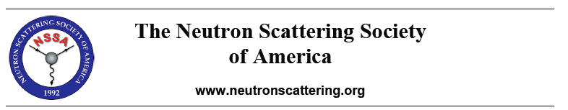NSSA Membership and Address Update Form
New Member □ Member Information Update□

First Name
Last name
Title
Department
Institution
Street Address
City
State/Province
Zip/Postal Code
Country
Telephone
FAX
E-Mail

Area of Principal Interest (Select One):
Biology □ | Chemistry □ | Crystallography □
Engineering □ | Condensed Matter Physics □ | Fundamental Physics□
Ceramics□ | Metallic Materials□ | Polymers□
Other Materials Science □ | Instrumentation□ | Other □

Details of Neutron Techniques Used or Other Area(s) of Interest

